**STEPHEN OMONDI**

SUID: 946934043

Monday, January 13, 2020

2020-0108 IST 722 Data Warehouse

Course Instructor: Professor [Humayun Khan](https://2su.datascience.syr.edu/my/index.php?id=1180)

**PART 3:**

|  |  |  |  |  |
| --- | --- | --- | --- | --- |
| **Table** | **Type** | **Row Count** | **Business Key** | **One Row Is** |
| Employees | Master Data | 9 | None (PK used) | An employee |
| EmployeeTerritories | Business Process | 49 | None (PKs used) | An employee assigned to a territory. |
| Customers | Master Data | 91 | Company Name | A company and all its points of contacts. |
| Suppliers | Business Process | 29 | Company Name | A supplier (A company) and all its points of contact. |
| Products | Master Data | 77 | None (PK used) | A product, its supplier, quantity per unit, price, whether it is discontinued or not, and units on hand. |
| Shipments (of Orders) | Business Process | 830 | None (PK used) | Individual orders and shipping details. |
| Details (of an Order) | Business Process | 2155 | None (PK used) | Each order, quantity in the order, price per unit and discount applied. |

1. **List the customer contact names and titles sorted by company name.**

SELECT c.ContactName, c.ContactTitle, c.CompanyName FROM Customers c

ORDER BY c.CompanyName ASC;

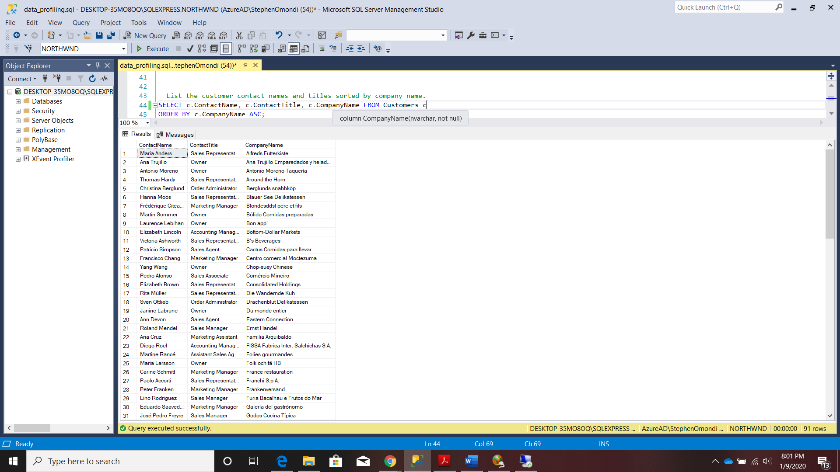

1. **Factoring in discounts, what is total amount of product sold?**

SELECT SUM((od.UnitPrice * od.Quantity) - (od.Discount * (od.UnitPrice * od.Quantity))) AS TotalAmount, SUM(od.Quantity) AS QuantityOrdered

FROM [Order Details] od;

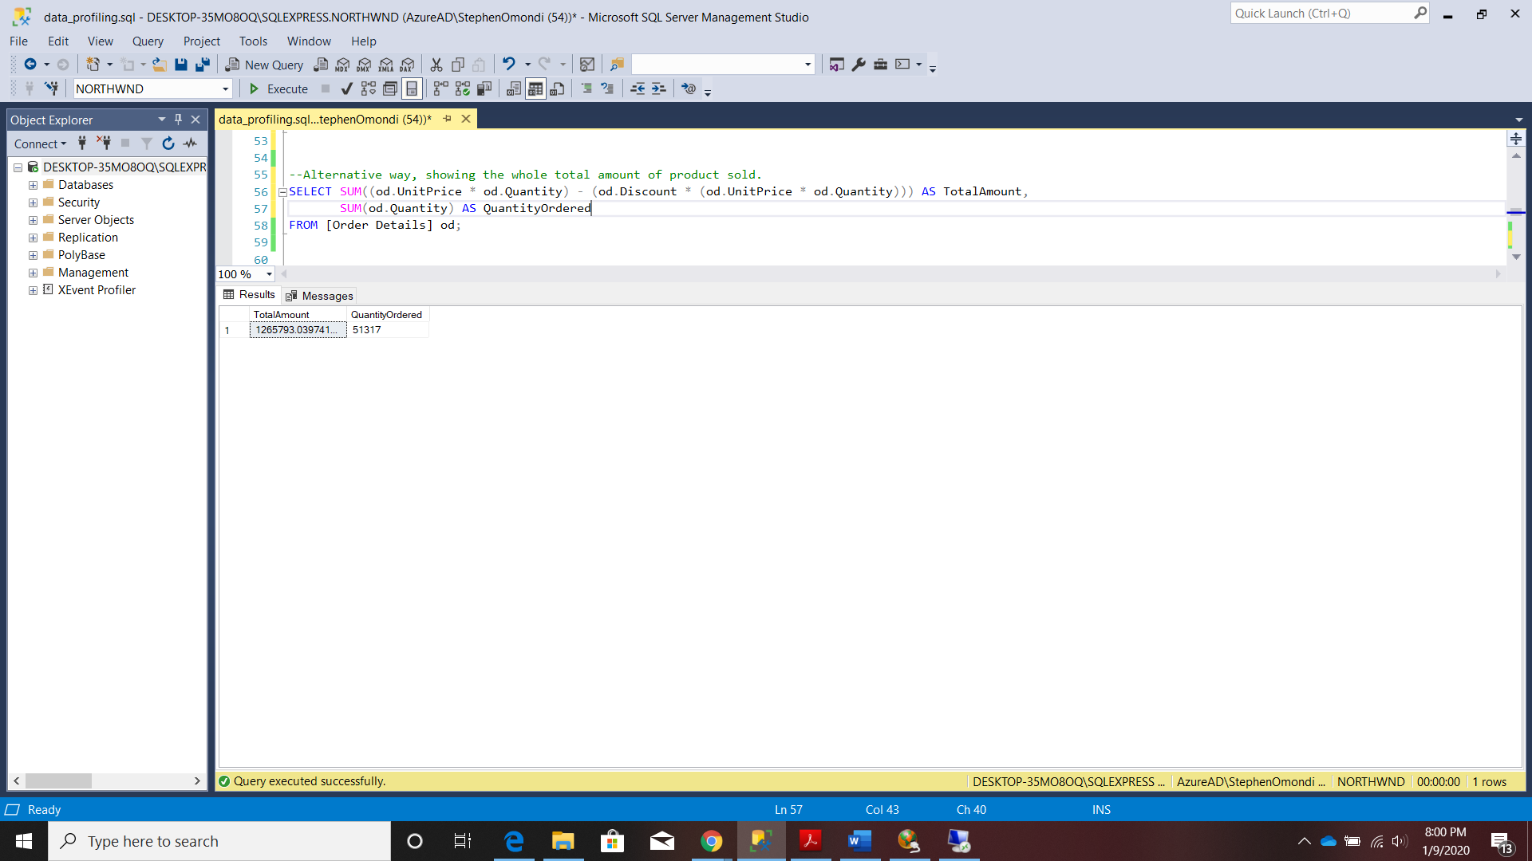

1. **Provide a list of product category names with counts of products in each category.**

SELECT c.CategoryName, COUNT(*) as productCount FROM Categories c

JOIN

Products p ON p.CategoryID = c.CategoryID

GROUP BY c.CategoryName

ORDER BY productCount;

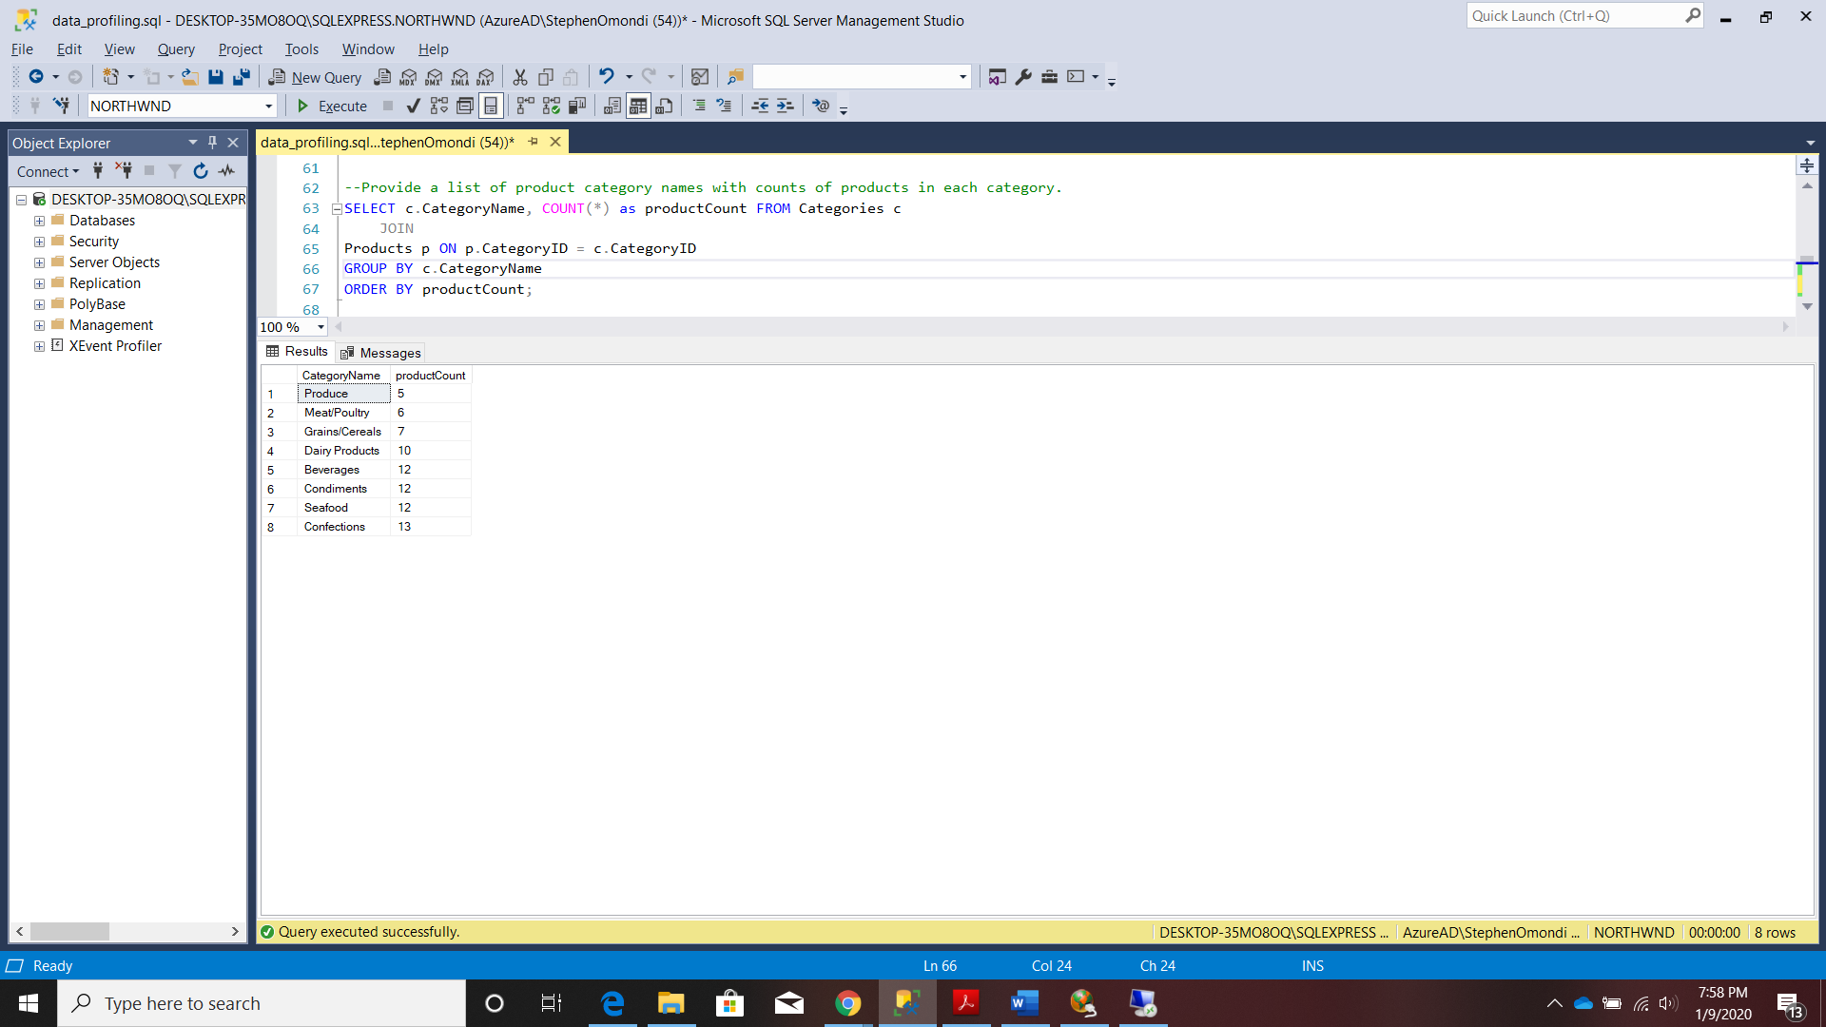

1. **Select a specific customer and display that customer’s orders with total amount of product sold for each order.**

SELECT c.CustomerID, o.OrderID, o.OrderDate, p.ProductName, od.Quantity, od.Discount,

((od.UnitPrice * od.Quantity) - (od.Discount * (od.UnitPrice * od.Quantity))) as OrderTotal

FROM Customers c

JOIN Orders o ON o.CustomerID = c.CustomerID

JOIN [Order Details] od ON od.OrderID = o.OrderID

JOIN Products p ON p.ProductID = od.ProductID

WHERE c.CustomerID = 'BOLID'

ORDER BY o.OrderDate DESC;

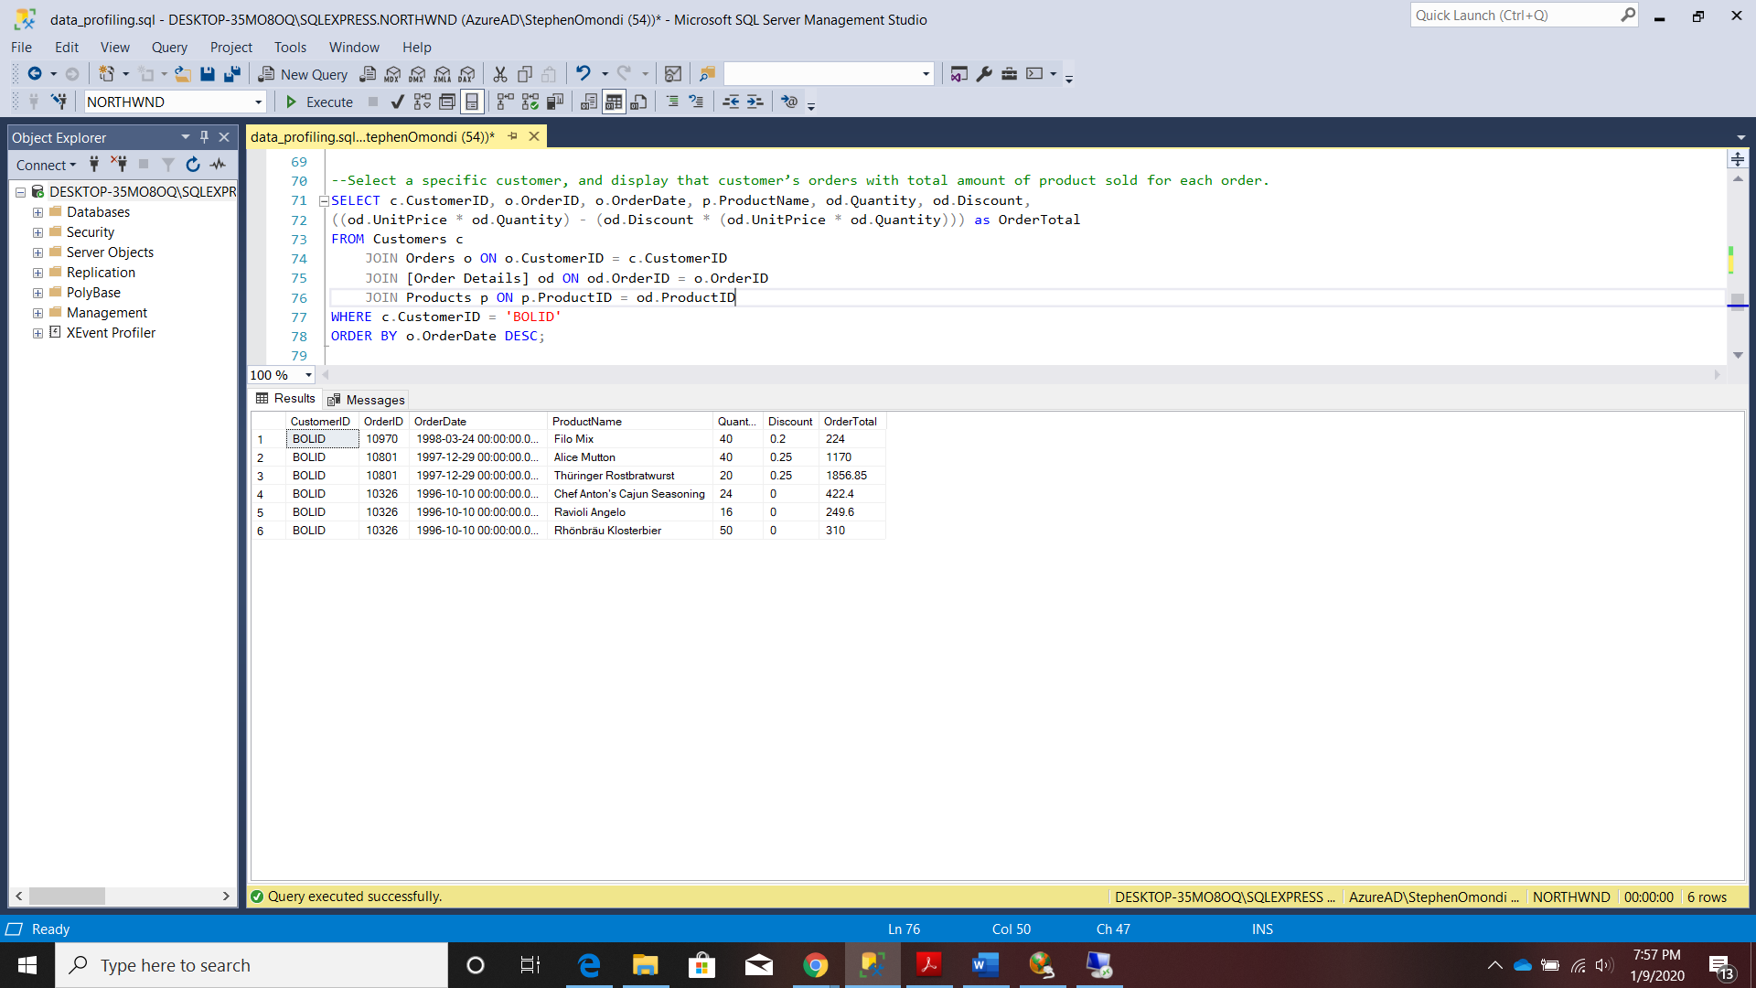

1. **Select a specific employee and each order, how it was shipped (shipvia), the company who shipped it, and the total number of days elapsed from order date to shipped date.**

SELECT e.LastName, e.FirstName, o.ShipVia, o.ShipName, S.CompanyName AS shippingCompany, o.OrderDate, o.ShippedDate,

DATEDIFF(day, o.OrderDate, o.ShippedDate) AS DaysElapsed

FROM Employees e

JOIN Orders o ON o.EmployeeID = e.EmployeeID

JOIN Shippers S on S.ShipperID = o.ShipVia

WHERE e.LastName = 'Davolio'

ORDER BY DaysElapsed DESC;

